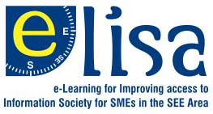
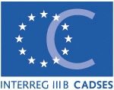

Improving access to Infomation Society for SMEs
in the South-East European Area through E-learning
-ELISA Project-

Training seminar for SMEs in the utilization
of Information and Communication Technologies, for free.

The aim of the ELISA project is to assist small-medium sized enterprises (SMEs) in South-East Europe, in gaining access to knowledge and the information society through close cooperation of academic and business communities at a transnational level.
This will be achieved through the organization of a training seminar in order for the participating SMEs to get acquainted to the utilization of Information and Communication Technologies and the Internet, in their daily operations.
The training seminar will be comprised of a total of 10 hours (divided into sessions). Participation in the seminar is for free.
Upon completion of participating in the seminar, each SME will receive a certification of attendance.
The topics that will be covered will be basically: Utilization of the Internet, using the e-mail, developing and exploiting a web-site, applying e-commerce, for the commercial benefit of the SME.
In the training seminars of the ELISA project may apply for participation SMEs from rural and distant areas of the country.
In order to apply for participation, the interested SMEs should contact: (SAITC, Stanislava Ezekieva,tel. +3592 9492312, e-mail : s.ezekieva@ict.bg , or they can access the application electronically in the web-site: http://www.ist.bg/en/default.htm
Deadline of applying for participating in the seminars is the 20 March of 2006.
The ELISA project is implemented through financial assistance of ERDF funds, within the framework of the INTERREG III B CADSES Neighborhood Programme in accordance with Commission Regulation (EC)
No 1159/2000.

